**3GPP T****SG-RAN WG4 Meeting #114** **R4-2504430**

**Wuhan, China, 7 – 11th April 2025**

**Source:** **BT**

**Title: Simulation Results for SCM Comparison and Alignment**

**Agenda item: 7.16.2**

**Document for: Information**

1. Introduction

The Study on Spatial Channel Modelling for Demodulation Performance Requirements was approved at RAN#104 [1], and RAN4#112, RAN4#112b, RAN4#113 and RAN4#114 approved way forward agreements [2-5] respectively. This contribution provides simulation results updated from [6], based on agreements in [5].

1. Simulation Results
   1. Simulation setup

Simulation parameters are provided in Annex A, where the agreements from [5] are integrated in the table. Throughout the simulation results presented in this contribution we use a CDL-C channel model based on TR 38.827, and AAV 1Y configurations from [5], including the 32Tx AAV. In our current simulation method, a constant noise power level is utilized while sweeping across different transmit powers, to achieve the target SNR at the receiver ports. The long-term SNR is calculated using the formula

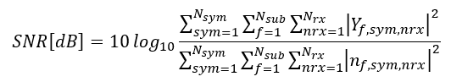

The throughput results are normalized with respect to the maximum achievable throughput in the given configuration. Perfect channel estimation is used in the simulation results provided in this contribution. Fixed PMI is selected as the most frequent PMI choice under follow PMI case in a given configuration.

* 1. Single-User PDSCH/PMI: 4Rx Rank 4 and 2

Results in this section provide the throughput performance of Type I codebook (random and follow) and eType 2 (follow) for Rank 2 transmissions, assuming both 10Hz and 100Hz Doppler effects. Results for Rank 4 were not available at the time of preparation of this contribution. We are aiming to provide results at the RAN4#114-bis meeting.

Figure 1. SU PMI: 2 Layer, 10Hz Doppler

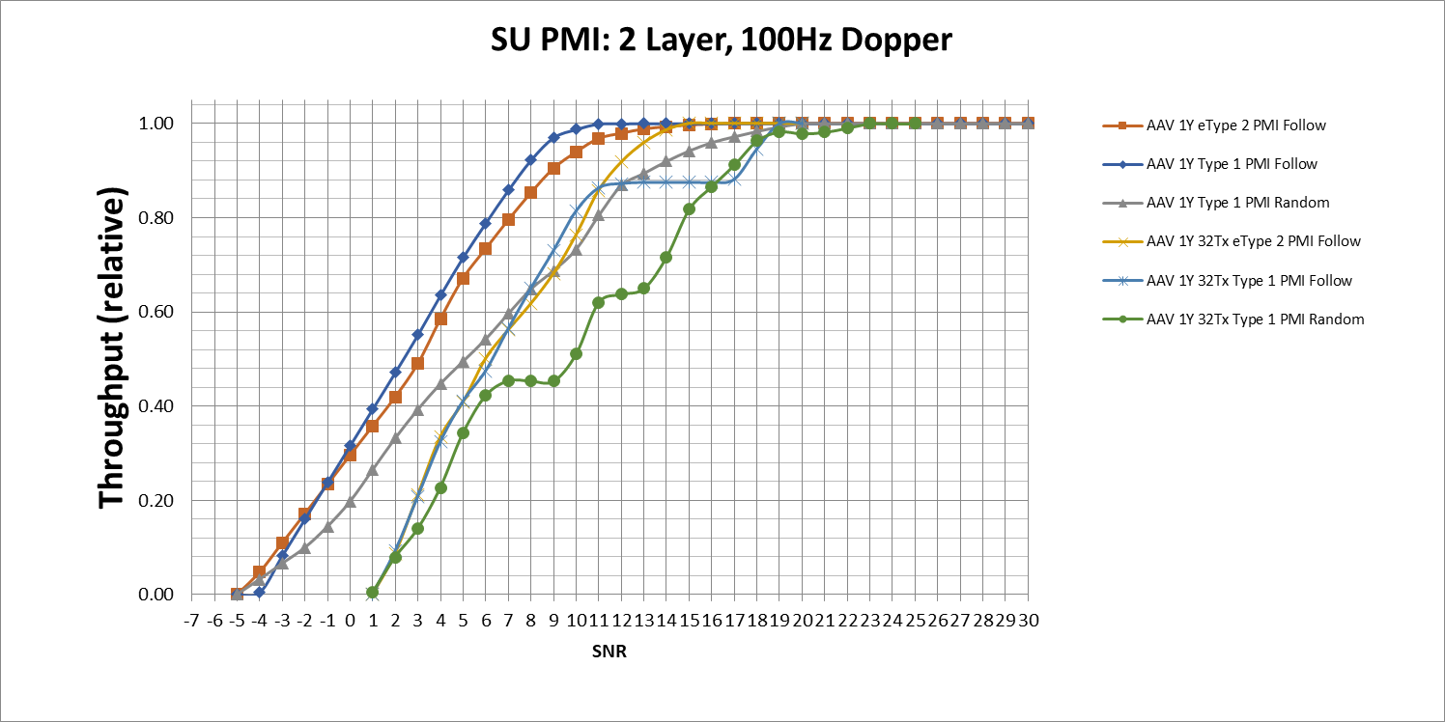

Figure 2. SU PMI: 2 Layer, 100Hz Doppler

* 1. Multi-User PDSCH:

At the time of preparation of this contribution there was a known issue in our IRC receiver implementation, preventing the implementation to reach maximum throughput in an MU-MIMO scenario. However, we still provide current results for information here and aim to provide updated results at the RAN4#114 meeting.

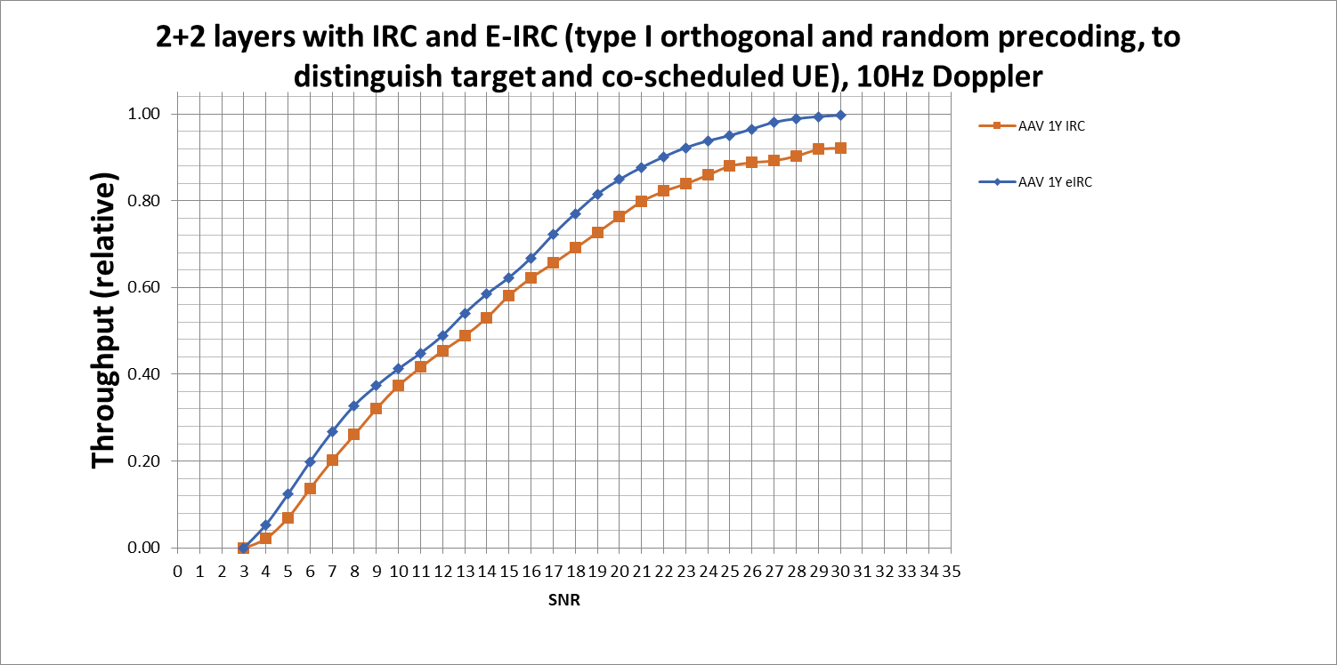

Figure 3. MU PDSCH, MMSE-IRC and MMSE-eIRC Receivers, orthogonal precoder for co-scheduled UE, 10 Hz Doppler

1. Conclusion

This contribution provides throughput simulation results for the use cases in [5]. Updated results will be submitted to RAN4#114-bis meeting through the results collection template in R4-2504429.

1. References
2. RP-241610, “3GPP Work Item Description: Study on spatial channel model for demodulation performance requirements”, Nokia, BT Plc, AT&T, Bell Mobility, Bouygues Telecom, China Telecom, CMCC, Deutsche Telekom, Ericsson, Intel Corporation, KDDI, Keysight, KT Corp., MediaTek, NTT Docomo, Orange, Qualcomm, Rohde & Schwarz, Samsung, SK Telecom, Spark NZ, Telecom Italia, Telefonica, Telenor, Telia Company, Telstra, T-Mobile USA, Verizon, Vodafone, ZTE Corporation
3. R4-2413606, Way Forward for [112][327] FS_NR_demod_SCM, RAN4#112, Aug 2024.
4. R4-2416591, Way Forward for [112b][328] FS_NR_demod_SCM, RAN4#112b, Oct 2024.
5. R4-2419782, Way Forward for [113][320] NR_SCM, RAN4#113, Nov 2024.
6. R4-2502378, Way Forward [114][322] NR_SCM, RAN4#114, Feb 2025.
7. R4-2501744, Simulation Results for SCM Comparison and Alignment, BT Plc, RAN4#114, Feb 2025.
8. Annex A: CDL channel model parameters

|  |  |  |  |  |  |
| --- | --- | --- | --- | --- | --- |
| **Parameter** | | **SU-MIMO PDSCH (FR1)** | **SU-MIMO PMI (FR1)** | | **MU-MIMO PDSCH (FR1)** |
| Duplex mode | | FDD | | | |
| FR / Carrier frequency | | FR1 / 3.5 GHz | | | |
| UE receiver type | | IRC Baseline | IRC Baseline | | IRC, eIRC |
| Number of Tx Ports | | 8,4 | 32,8 | | 4 |
| Number of Rx Ports/Antennas | | 8,4 | 4 | | 4 |
| Number of layers | | 8,4 | 4,2 | | 2+2 |
| PMI | | Random, FFS Fixed | Follow, Random | | UE1: Random  UE2: Random and not equal to UE1,  Orthogonal |
| Waveform | | CP-OFDM with normal CP | | | |
| Channel Bandwidth/SCS | | 40MHz/30kHz | | | |
| MCS | | 13 (64 QAM table) | | | |
| PDSCH configuration | Mapping type | Type A | | | |
| k0 | 0 | | | |
| Starting symbol (S) | 2 | | | |
| Length (L) | 12 | | | |
| PDSCH aggregation factor | 1 | | | |
| Resource allocation type | Type 0 | | | |
| VRB-to-PRB mapping type | Non-interleaved | | | |
| VRB-to-PRB mapping interleaver bundle size | N/A | | | |
| PDSCH DMRS configuration | DMRS Type | Type 1 | | | |
| Number of additional DMRS | 1 | | | |
| Maximum number of OFDM symbols for DL front loaded DMRS | 2 (for rank > 4)  1 (for rank <= 4) | | | |
| Codebook configuration | CodebookType | type-I-SP | type-I-SP, eType-II | | type-I-SP |
| Codebook configuration | For 8Tx  (N1,N2,O1,O2) = (4,1,4,1)    For 4Tx  (N1,N2,O1,O2) = (2,1,4,1) | For typeI-SP:  (N1,N2,O1,O2) = (4,1,4,1)    For eType-II:  8Tx: (N1,N2,O1,O2) = (4,1,4,1)  32Tx: (N1,N2,O1,O2) = (8,2,4,4)  paramCombination-r16=6 (L=4, pν=1/2, β=1/2) | | (N1,N2,O1,O2) = (2,1,4,1) |
| PDSCH DMRS Precoding Configuration | | For Random precoding: for every PRB Bundle (size=2)    For Fixed precoding: Wideband PMI | For typeI-SP (random and follow): Wideband PMI | | For Random precoding: for every PRB Bundle (size=2) |
| NZP CSI-RS for CSI acquisition | CSI-RS resource Type | Periodic | | | |
| Number of CSI-RS ports (X) | 4 CSI-RS Ports (2,1) for 4 Layer  8 CSI-RS Ports (4,1) for 8 Layer | 8 CSI-RS Ports (4,1) | | TBD |
| Density (ρ) | 1 | | | |
| Periodicity | 8 slots | | | |
| First OFDM symbol in the PRB used for CSI-RS (l0) | (13) | | | |
| CQI/RI/PMI delay | | N/A | 6.5 ms | N/A | |
| Number of HARQ Processes | | 8 | | | |
| Maximum HARQ transmissions | | 4 | | | |
| Channel Models | | The purpose of the study item. | | | |
| Testing Metric | | Full Throughput Curves | | | |
| Channel Geometry (CDL) | LCS UE | α = 180°, β=0°, γ = 90° | | | |
| LCS gNodeB | α = 0°, β=10°, γ = 0° | | | |
| GCS UE | Height = 1.5 m; Azimuth = 0; X Coordinate = 100 m | | | |
| GCS gNodeB | Height = 25 m; Azimuth = 0; X Coordinate = 0 m | | | |
| BS Antenna Polarisation | (+45, -45) | | | |
| BS Radiation Pattern | defined in TR38.901 Table 7.3-1. | | | |
| UE Antenna Polarisation | (0, 90) | | | |
| UE Antenna Radiation Pattern | Omnidirectional | | | |
| Antenna Panel Placement | YZ Plane | | | |